 

**Batch: B-1              Roll No.:  16010122104**

**Experiment No. 3**

**Grade: AA / AB / BB / BC / CC / CD /DD**

**Signature of the Staff In-charge with date**

|  |
| --- |
| **Title: Implementation of Quick sort/Merge sort algorithm** |

**Objective:** To learn the divide and conquer strategy of solving the problems of different types

**CO to be achieved:**

|  |  |
| --- | --- |
| CO 2 | Describe various algorithm design strategies to solve different problems and analyze Complexity. |

**Books/ Journals/ Websites referred:**

1. **Ellis horowitz, Sarataj Sahni, S.Rajsekaran,” Fundamentals of computer algorithm”, University Press**
2. **T.H.Cormen ,C.E.Leiserson,R.L.Rivest and C.Stein,” Introduction to algortihtms”,2nd Edition ,MIT press/McGraw Hill,2001**
3. **http://en.wikipedia.org/wiki/Quicksort**
4. **https://www.cs.auckland.ac.nz/~jmor159/PLDS210/qsort.html**
5. **http://www.cs.rochester.edu/~gildea/csc282/slides/C07-quicksort.pdf**
6. **http://www.sorting-algorithms.com/quick-sort**
7. **http://www.cse.ust.hk/~dekai/271/notes/L01a/quickSort.pdf**
8. **http://en.wikipedia.org/wiki/Merge_sort**
9. **http://www.personal.kent.edu/~rmuhamma/Algorithms/MyAlgorithms/Sorting/mergeSort.htm**
10. **http://www.sorting-algorithms.com/merge-sort**
11. **http://www.princeton.edu/~achaney/tmve/wiki100k/docs/Merge_sort.html**

**Pre Lab/ Prior Concepts:**

Data structures, various sorting techniques

**Historical Profile:**

**Quicksort and merge sort are** divide**-**and-conquer sorting algorithm in which division is dynamically carried out. They are one the most efficient sorting algorithms.

**New Concepts to be learned:**

Number of comparisons, Application of algorithmic design strategy to any problem, Classical problem solving vs Divide-and-Conquer problem solving.

**Algorithm** **Recursive Quick Sort:**

**void** quicksort( Integer A[ ], Integer left, Integer right)

**//**sorts A[left.. right] by using partition() to partition A[left.. right], and then //calling itself // twice to sort the two subarrays.

{ **IF** ( left < right ) then

{ q = partition( A, left, right);

quicksort( A, left, q–1);

quicksort( A, q+1, right);

}

}

**Integer *partition(integer A*T[], Integer *left*, Integer *right*)**

*//This function*rarranges *A*[*left***..***right*] and finds and returns an integer *q*, such that *A*[*left*], ..., //*A*[*q*–1] **<**∼ *pivot*, *A*[*q*] = *pivot*, *A*[*q*+1], ..., *A*[*right*] > *pivot*, where *pivot* is the first element of //a[left…right], before partitioning**.**

{

pivot = A[left]; lo = left+1; hi = right;

**WHILE** ( lo ≤ hi)

{ **WHILE** (A[hi] > pivot) hi = hi – 1;

**WHILE** ( lo ≤ hi and A[lo] <∼pivot) lo = lo + 1;

**IF** ( lo ≤ hi) then swap( A[lo], A[hi]);

}

swap(pivot, A[hi]);

**RETURN** hi;

}

**The space complexity of Quick Sort: O(logn)**

// package Codes.Sorting;

import java.io.*;

import java.time.*;

import java.util.*;

import java.lang.Math;

public class quickSort {

    static void swap(int[] arr, int i, int j)

    {

        int temp = arr[i];

        arr[i] = arr[j];

        arr[j] = temp;

    }

    static int partition(int[] arr, int low, int high)

    {

        int pivot = arr[high];

        int i = (low - 1);

        for(int j = low; j <= high - 1; j++)

        {

            if (arr[j] < pivot)

            {

                i++;

                swap(arr, i, j);

            }

        }

        swap(arr, i + 1, high);

        return (i + 1);

    }

    static void quickSort(int[] arr, int low, int high)

    {

        if (low < high)

        {

            int pi = partition(arr, low, high);

            quickSort(arr, low, pi - 1);

            quickSort(arr, pi + 1, high);

        }

    }

    static void printArray(int[] arr, int size)

    {

        for(int i = 0; i < size; i++)

            System.out.print(arr[i] + " ");

        System.out.println();

    }

// Driver Code

    public static void main(String[] args)

    {

        Scanner sc = new Scanner(System.in);

        System.out.println("Enter number of elements: ");

        int N=sc.nextInt();

        int arr[];

        arr=new int[N];

        // System.out.println("Given Array");

        for(int i=0;i<N;i++)

        {

            double x=Math.random()*300;

            int num= (int)x;

            arr[i]= num;

        }

        printArray(arr,N);

        long start = System.nanoTime();

        quickSort(arr, 0, N - 1);

        System.out.println("Sorted array: ");

        printArray(arr, N);

        long end = System.nanoTime();

        long execution = end - start;

        System.out.println("Execution time: " + execution + " nanoseconds");

    }

}

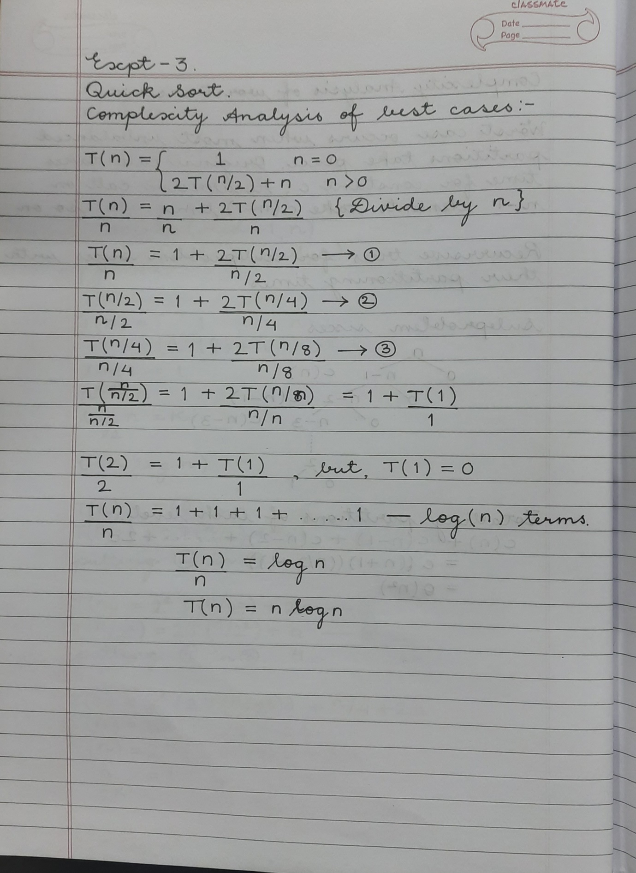

**Derivation of best case and worst-case time complexity (Quick Sort)**

**Algorithm Merge Sort**

MERGE-SORT (*A*, *p*, *r*)

// To sort the entire sequence A[1 .. n], make the initial call  to the procedure MERGE-SORT (*A*, //1, *n*). Array *A* and indices *p*, *q*, *r* such that *p* ≤ *q* ≤ r and sub array *A*[*p* .. *q*] is sorted and sub array //*A*[*q* + 1 .. *r*] is sorted. By restrictions on *p*, *q*, *r*, neither sub array is empty.

**//OUTPUT**: The two sub arrays are merged into a single sorted sub array in *A*[*p* .. *r*].

**IF** *p* < *r*                                                    // Check for base case  
         **THEN** *q* = FLOOR [(*p* + *r*)/2]                 // Divide step  
                 **MERGE** (A, *p*, *q*)                          // Conquer step.  
                 MERGE (A, *q* + 1, *r*)                     // Conquer step.  
                 MERGE (A, *p*, *q*, *r*)                       // Conquer step.

MERGE (*A*, *p*, *q*, *r*)

{

*n*1 ← *q* − *p* + 1  
      *n*2 ← *r* − *q*  
      Create arrays L[1 . . *n*1 + 1] and R[1 . . *n*2 + 1]  
      **FOR** *i* ← 1 **TO** *n*1  
            **DO** L[*i*] ← A[*p* + *i* − 1]  
      **FOR** *j* ← 1 **TO** *n*2  
            **DO** R[*j*] ← A[*q* + *j* ]  
      L[*n*1 + 1] ← ∞  
      R[*n*2 + 1] ← ∞  
    *i* ← 1  
    *j* ← 1  
    **FOR** *k* ← *p* **TO** *r*  
         **DO IF** L[*i* ] ≤ R[ *j*]  
                **THEN** A[*k*] ← L[*i*]  
                        *i* ← *i* + 1  
                **ELSE** A[k] ← R[j]  
                        *j* ← *j* + 1

}

**The space complexity of Merge sort: O(n)**

// package Codes.Sorting;

import java.util.*;

import java.lang.Math;

public class mergeSort {

    static void merge(int arr[], int l, int m, int r)

    {

        // Find sizes of two subarrays to be merged

        int n1 = m - l + 1;

        int n2 = r - m;

        /* Create temp arrays */

        int L[] = new int[n1];

        int R[] = new int[n2];

        /*Copy data to temp arrays*/

        for (int i = 0; i < n1; ++i)

            L[i] = arr[l + i];

        for (int j = 0; j < n2; ++j)

            R[j] = arr[m + 1 + j];

        /* Merge the temp arrays */

        // Initial indexes of first and second subarrays

        int i = 0, j = 0;

        // Initial index of merged subarray array

        int k = l;

        while (i < n1 && j < n2) {

            if (L[i] <= R[j]) {

                arr[k] = L[i];

                i++;

            }

            else {

                arr[k] = R[j];

                j++;

            }

            k++;

        }

        /* Copy remaining elements of L[] if any */

        while (i < n1) {

            arr[k] = L[i];

            i++;

            k++;

        }

        /* Copy remaining elements of R[] if any */

        while (j < n2) {

            arr[k] = R[j];

            j++;

            k++;

        }

    }

    // Main function that sorts arr[l..r] using

    // merge()

    static void sort(int arr[], int l, int r)

    {

        if (l < r) {

            // Find the middle point

            int m =l+ (r-l)/2;

            // Sort first and second halves

            sort(arr, l, m);

            sort(arr, m + 1, r);

            // Merge the sorted halves

            merge(arr, l, m, r);

        }

    }

    /* A utility function to print array of size n */

    static void printArray(int arr[])

    {

        int n = arr.length;

        for (int i = 0; i < n; ++i)

            System.out.print(arr[i] + " ");

        System.out.println();

    }

    // Driver code

    public static void main(String args[])

    {

        Scanner sc = new Scanner(System.in);

        System.out.println("Enter number of elements: ");

        int N=sc.nextInt();

        int arr[];

        arr=new int[N];

        // System.out.println("Given Array");

        for(int i=0;i<N;i++)

        {

            double x=Math.random()*300;

            int num= (int)x;

            arr[i]= num;

        }

        printArray(arr);

        long start = System.nanoTime();

        // mergeSort ob = new mergeSort();

        sort(arr, 0, arr.length - 1);

        System.out.println("\nSorted array");

        printArray(arr);

        long end = System.nanoTime();

        long execution = end - start;

        System.out.println("Execution time: " + execution + " nanoseconds");

    }

}

**Derivation of best case and worst-case time complexity (Merge Sort)**

**Example for quicksort/Merge tree for merge sort:**

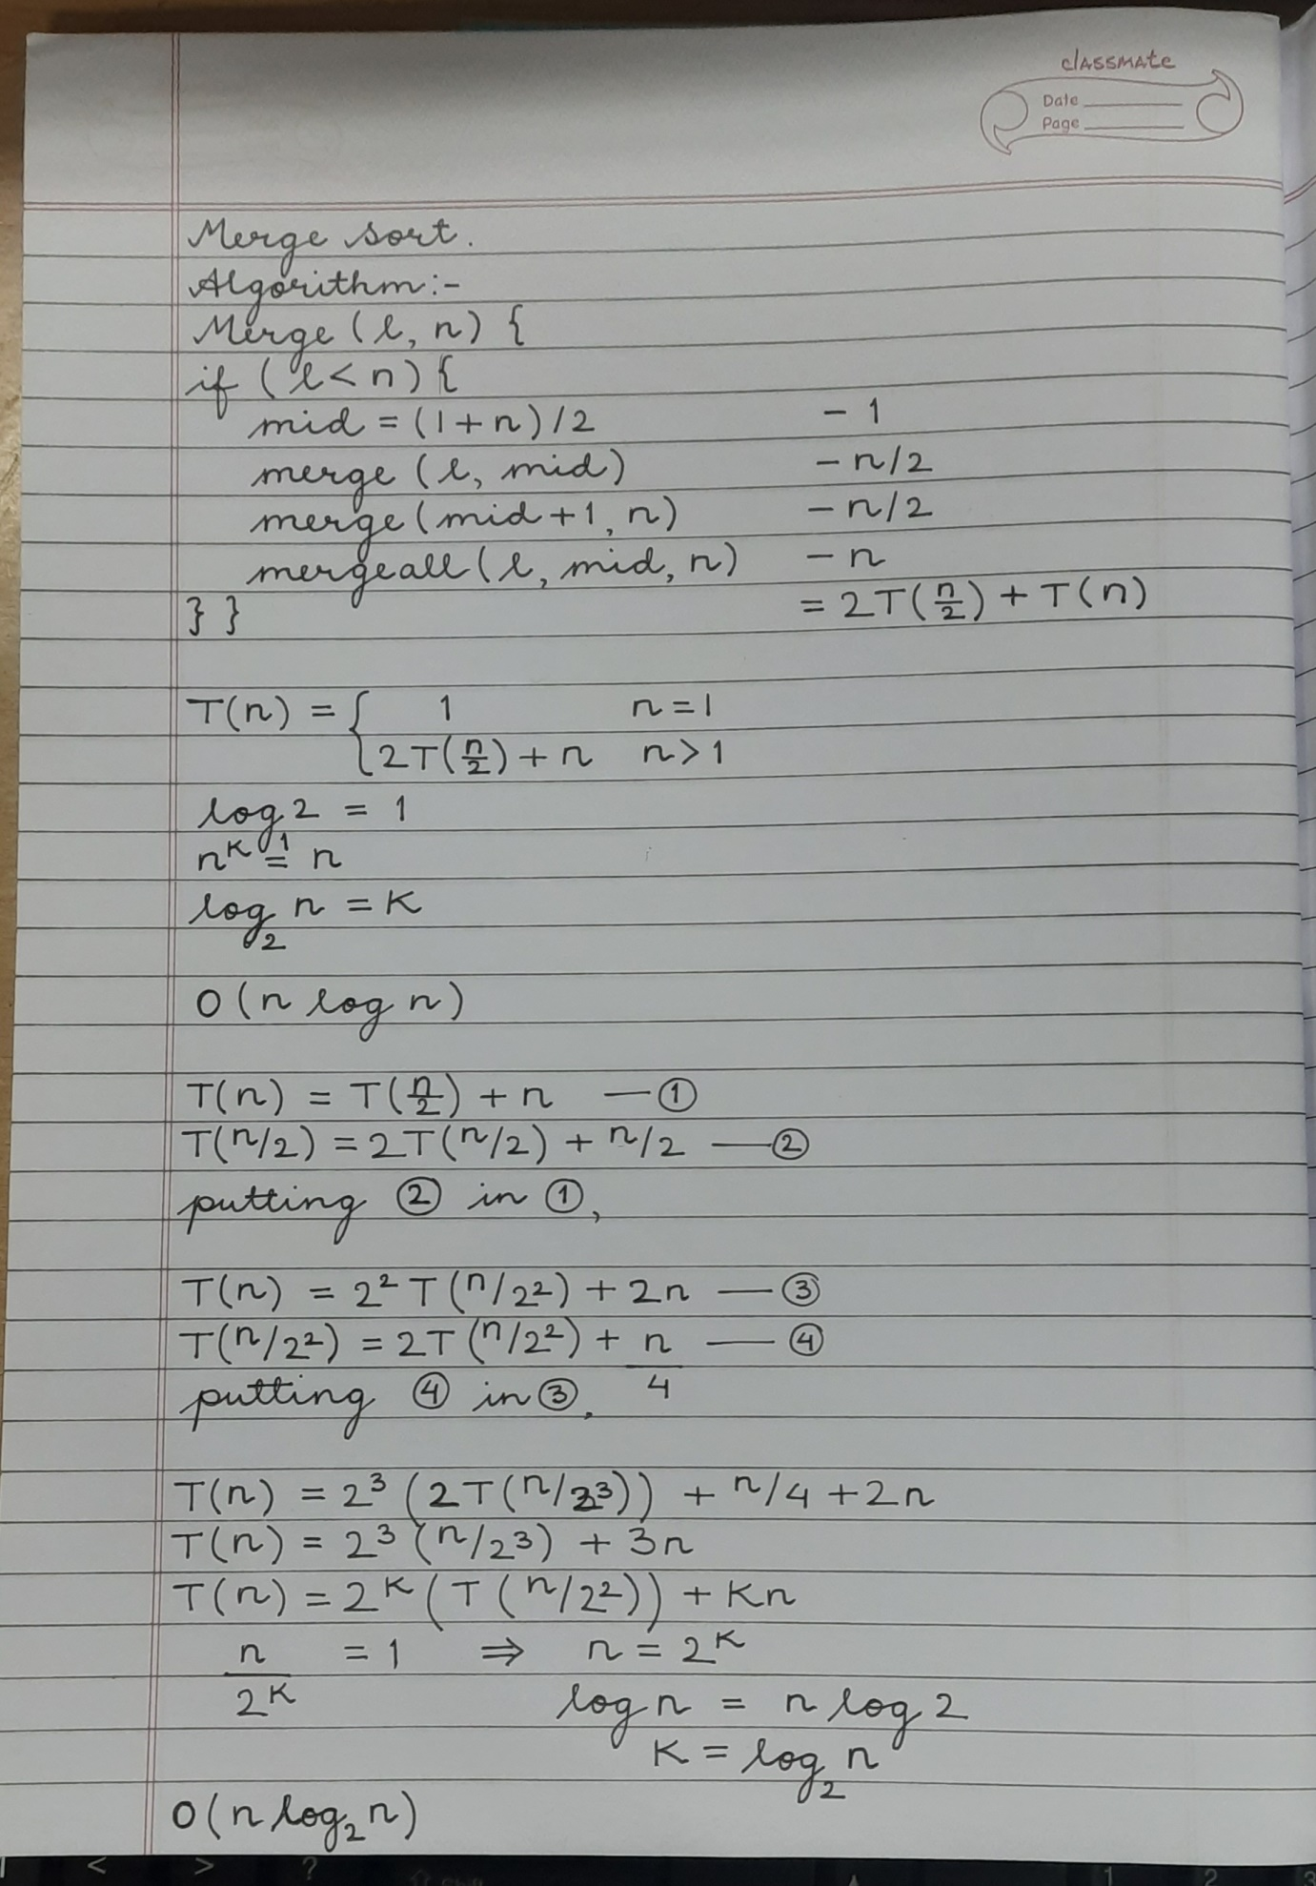

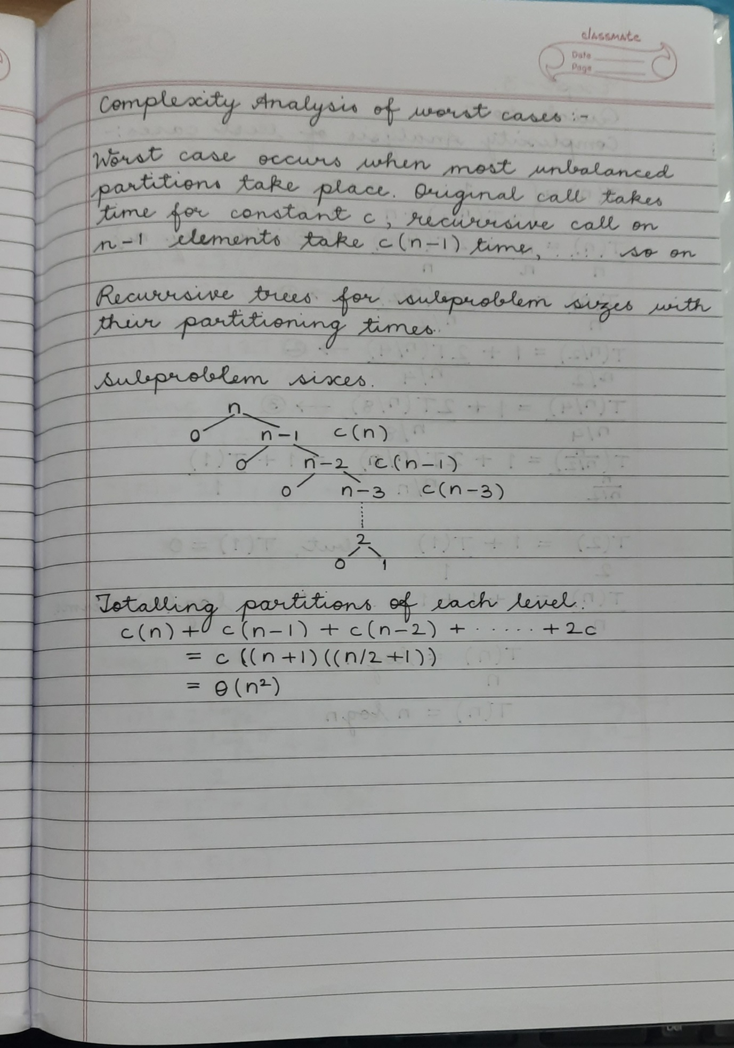

**CONCLUSION:**

I’ve understood the concept, implementation and derivation of time complexities for Quick Sort and Merge Sort algorithms.